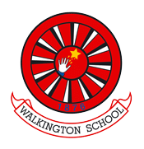
Year 2 Summer 1:
R.E.
Questions, questions

Prior Learning

Recap learning from Year 1 where pupils found out about creation stories from different religions and traditions, attempting to explain how the world began. This unit encourages children to develop and explore their own Big Questions about how the world and other things came about. Consider some of the answers faith members may offer and celebrate the idea that people may think differently and that it’s OK to disagree. Pupils ask what matters to them - questions of meaning, purpose and truth. Use strategies such as Philosophy for Children (P4C), Godly Play and guided visualisations to help children raise their own questions and offer possible answers. By the end of this unit, pupils should be able to ask and respond to ultimate questions, and know the answers that different religions and other worldviews offer.
Key vocabulary for this unit

God, creation, universe, cycle of life
Learning Sequence

Who is god? Where is god? How was the world created? | - Ask the children how they think the world was created  - Look at the Christian ‘Creation Story.’ (Taken from Twinkl) Can they order the creation story?  - ideas about where the world came from  - Look at a Hindu creation story – compare to Christian  - a non-religious or traditional story about how the world was created
Why do bad things happen? (including death, as appropriate) | - consider the biggest question they can think of, thinking especially about questions that no one can answer  - Listen to the book https://www.youtube.com/watch?v=htpTDbIQzgo ‘why do the stars come out at night?’ Can any of the questions in this book be answered?  - Children to sit with whiteboards in ‘circle time’. Talk about what makes a ‘big question’ giving some examples to sort out: which of these is the biggest question: - What type of animal is this? / Why are there different sorts of animals on this earth? - Do you like to eat sweets? / Why are sweets so tasty? - What colour is the chair? / What is the chair made of? / What is the story of this chair? Why do we have a king or queen? Where does the sky end and space begin? etc • Ask children (think / pair / share is good) to think of four big questions, one each about themselves, other people, the Earth and God. Get them written into the question marks, or onto the whiteboard. Choose together which ones are the biggest of all. • Then introduce the idea that sometimes life makes us ask questions we don’t know the answers to: encourage pupils to think of some examples from their own experience e.g. How does the oak tree get into the acorn? How do flowers grow? Why did my hamster die? What makes the sun come up in the morning? Why is food nice? • Use the book ‘Why Do Stars Come Out at Night?” as an aid. Or a similar story. Children could suggest answers to the questions on each page before turning over to reveal the ‘answer’: whose answers do pupils like best? Can they think of some more questions?
Pose questions such as: Why don’t some people have enough food/shelter? Why do earthquakes happen? | - Look at what is going on in the world around us to help talk about these conversation points  - Give the children flashcards with some tricky questions on them to see if they can talk to a partner about the questions and if they know any answers or ideas about them.  - Why are some people rich and some people poor? Why is there so much pollution in the sea? Why do earthquakes/volcanoes/hurricanes happen?  - Ch – write their ideas on their cards and report back to the class.
Where do religious people look to find some answers to Big Questions? | 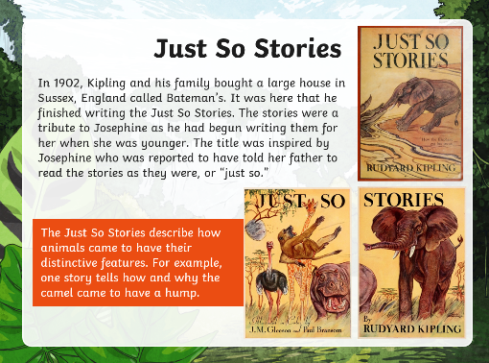  - what we can learn from the ‘Just So’ stories by Rudyard Kipling?  - Read some of the Just so stories together and talk to the children about the big questions Kipling is trying to answer. He obviously uses his imagination to amuse his child but sometimes even scientists don’t know the answers to these questions.  - Think about where Christians get their answers to big questions and also other religions. How does it make people feel to be able to answer a big question?
Where do people without a religion get their answers? | - Take a Big Question and illustrate it with a variety of worldview responses and some Big Answers How was the world created? Answer using scientific knowledge.  - How did life on earth begin?  - Why do the stars shine?  - https://www.twinkl.co.uk/resource/ks1-religious-and-non-religious-world-views-powerpoint-t-tp-2664283
Assessment milestones
Skills:  ask and talk about Big Questions and suggest some answers  identify names for god in different faiths  express what believers say god is like |  | Knowledge:  understand that some questions have no simple answers  know that religions may offer different answers to the same question

